**Technical Document – Annexure I**

**of**

**Marketplace Website**

**Contents**

Annexure I 3

1. Project Overview 3

2. Technologies 4

3. Features and Scope of Work 5

3.1. User Flow of Website 5

3.2. Features for Website 8

3.3. Administrator Web Panel 9

4. Draft Delivery Timeline 11

5. Project Management 12

6. Proposed Team of Project 13

7. Assumptions and Constraints 13

7.1. Assumptions 13

7.2. Constraints 13

# Annexure I

# Project Overview

* **Business Need**

The client wants to develop an information website as a marketplace for buying and selling companies which can provide comprehensive information about each listed company including its category, industry analysis, and region.

* **Solution Suggested**

As a solution we are suggesting to develop the website on python with database PostgreSQL.

* **Stakeholders**

|  |  |
| --- | --- |
| **Actor** | **Task** |
| User Type 1 | Buyers, who can get the information about the companies and make a request to buy them by filling the require details about themselves. |
| User Type 2 | Sellers can post their company for selling and the platform will help them to give a section to advertise the company. |
| Admin | Admin will manage the website from backend |

* **Project Scope and Development Deliverables**

This project scope comprises of the following components to deliver:

* Design and development of website for end users
* Development and Integration of API
* Development of Admin Web Panel

# Technologies

|  |  |
| --- | --- |
| **Development Phases** | **Tools & Technology** |

|  |  |  |
| --- | --- | --- |
| **Development Phases** | | **Tools & Technology** |
| Requirement  Gathering and Analysis | Proposal Drafting, SRS Writing and User Flow Diagram | Microsoft Office Word 2019 / Microsoft Office Presentation 2019 / Microsoft Office Vision 2019 |
| Development | Website | Python/Django |
| Web Backend | Python/Django |
| Database | PostgreSQL |
| Browser | Google Chrome, Safari, Mozilla Firefox |
| Quality Assurance  & Testing | Test Cases | MS Office Excel 2019 |
| Testing | Manual |

# Features and Scope of Work

## User Flow of Website

* **Header**

The header section of the website will contains the following and it will acts as the first point of interaction, offering users a quick overview and facilitating easy navigation to various sections of the site.

* + Logo
  + Company Information
  + Navigation menu
    - Home Page
    - Marketplace
    - Services
    - About us
    - Articles/ To know
    - CTAs
      * Contact us
      * Others
* **Footer**

The website footer will located at the bottom of a web page and typically contains essential links, copyright information, and contact details of the company.

* + Company details
    - Name
    - Address
    - Contact
  + Quick links
    - About us
    - Privacy Policy
  + Social media links (If any)
* **Home Page/logo**
  + **Banner section**
    - The top section of the page can feature a headline, subhead line, a call-to-action (CTA) button, and compelling visuals (images, videos, or sliders).
  + **Hero section**
    - The hero section will conveys the core message of the brand and letting visitors know what the website or business is about.
  + **Call-to-action**
    - Contact Now
  + **Services offered section**
    - This section will give the key reference of services with images, brief descriptions, and CTAs for further exploration.
  + **Articles / To know Section**
    - The section will give a highlights to the articles presented on the platform.
* **Marketplace Page**

The Marketplace page will serve as a virtual space where buyers and sellers can search and post their companies for advertising on the platform. It will also allow buyers to browse through current advertisements of companies available for sale, making it easier for them to find suitable options.

Additionally, the platform will allow for sellers to showcase their companies and attract potential buyers.

Users can apply the following filters to find the suitable company for themselves.

* + Category
  + Industry
  + Region
  + Min Price
  + Max Price
* **About us**

The about us page will offers a concise presentation of key information about the platform and business. It includes details such as the business's approach, experts, partners and frequently asked questions.

* + About us page will divided in to these different pages or section.
    - Our Approach
    - Experts
    - Partners
    - Frequently asked questions
* **Services Page**

The page will outlines the primary offerings or key areas of expertise and services provided by the platform.

* + Modules
  + Sell Company
  + Buy Company
* **Articles/To know**

The section provide the information where users can access articles and guides that offer valuable insights and tips on the buying or selling process helping them make informed decisions.

* **CTAs – Contact Forms**

Contact forms section will help the users to reach out to the support team and they can fill the details send them to the team for further processes.

## Administrator Web Panel

The back end of the platform will be power packed with an administrative panel to manage the updates of data at the application level, website level and as well as back end.

Following would be the key functionalities:

* **Login**

Admin will be able to login using username & password.

* **Users and Content Management**

The admin will have various functionalities to manage and control the website's content, and manage users.

* Admin will be able to manage the sellers and Buyers list including contact information.
* Admin can monitor user activities and access logs.
* Admin can Manage and moderate articles, posts, and other content on the platform.
* Admin can Control the visibility of content and ensure it complies with platform guidelines.
* **Marketplace Management**

The section provide the assess to the following things to the admin-

* Admin will review and approve/reject company listings posted by sellers.
* Admin can manage categories and industries available for selection.
* Admin will be able to monitor and moderate buyer and seller interactions.
* **FAQs and Documentation**
* Admin can manage and update the content on the FAQ and documentation pages from this section.
* **Category management**
* It includes managing categories, subcategories for the contact forms.
* **Request management**
* The section help the admin to managing and processing user requests within the marketplace platform.
* **Logout**

The section allow the admin to logout form the platform.

***NOTE- Client must provide all the 3rd Party plugins or APIs required for the development of the website.***

# Draft Delivery Timeline

|  |  |
| --- | --- |
| **Planned Project Start Date** | **Scheduled Project Completion Date** |
| **Project Duration\*** | 89 business days |
| **11-Jan-24** | 14-May-24 |

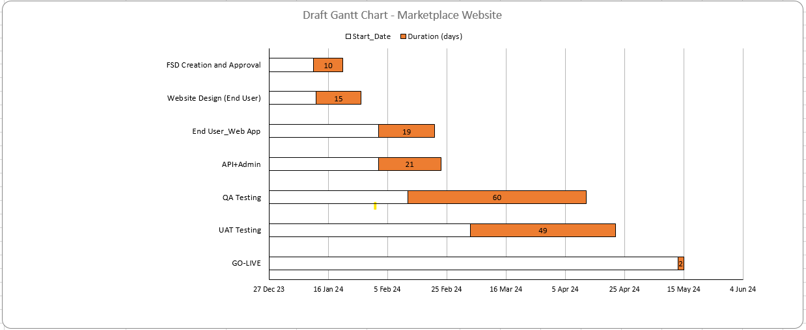

*Project Duration would be met with a condition that the client responses are received   
 on time.

# Project Management

|  |  |  |  |
| --- | --- | --- | --- |
| **Before Project is awarded** | | | |
| **Business Analysis** | **Project Management / Software Development** | **Business Development / Sales** | **Accounting** |
| 1. Project Identify / Analysis 2. Develop one-page proposal overview 3. Create project management overview 4. **Moreno** assigned to business manager GBM   *GBM: Global Business Manager* | 1. Project Evaluation by technical teams 2. Introduction call 1 on 1 interaction with **Moreno** 3. System appropriate services determined 4. Requirements / System application architecting 5. Project needs analysis 6. Detailed proposal development 7. Cost and Time effort estimation | 1. Introduction call 2. Deliverables discussed with **Moreno** 3. Milestones discussed 4. Project success discussed 5. Future growth alignment 6. Detailed proposal provided 7. Payment instructions | 1. Invoice submitted to **Moreno** 2. Payment received 3. Payment confirmation sent to **Moreno** 4. Account forwarded to PM |

|  |  |  |  |
| --- | --- | --- | --- |
| **After Project is awarded** | | | |
| **Phase 1** | **Phase 2** | **Phase 3** | **Phase 4** |
| 1. Project manager assigned 2. Project initiation/ introduction call 3. Online project profile created 4. Weekly project meetings scheduled 5. Reporting formats explained to Moreno | 1. Design, Development / technical teams assigned 2. Project start 3. **Moreno** feedback on weekly 4. Weekly project feedback session- 30 min 5. Reports available on-line 6. Online Rebel catering access of PM system application | 1. Testing / Quality Assurance 2. Live server   testing 3. Final bugs issues fixed 4. Campaign completed | 1. Periodic project maintenance 2. Data backups 3. Web site –System application upgrades 4. On line marketing ** Optional |

# Proposed Team of Project

The proposed team to achieve the deliverables in a time span of 18 Business Weeks   
 comprising of 40 hrs./week is as follows

|  |  |
| --- | --- |
| Designation | Availability |
| Project Manager | Part Time |
| Project Expert | Part Time |
| Designers | Full Time |
| Developers | Full Time |
| Quality Analyst | Full Time |

**IN WITNESS WHEREOF**, both parties here have to agree the finalized scope for this project as of the date.

**For: Moreno For: WebMobril Inc.**

Signature: Signature:

_________________________ ________________________